**KW-525SE Operation Instruction**

**KW-525SE Operation**

**Remove Tire**

1. Remove the balance paste weight, also the valve cap, the valve core, then make the tire fully air bleeding, finally take out of wheel rim’s central mark .

(Note: must wear the gloves without fur when you remove the valve, to avoid something else dropped into the valve.)

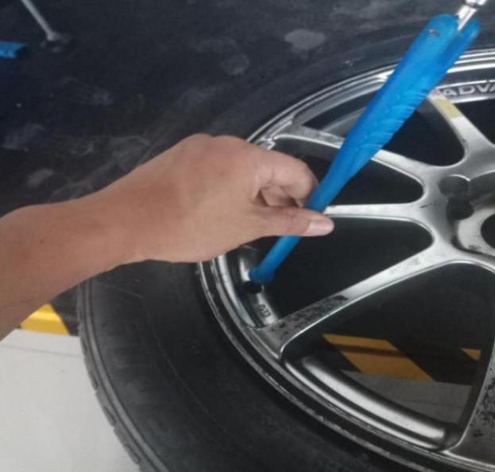

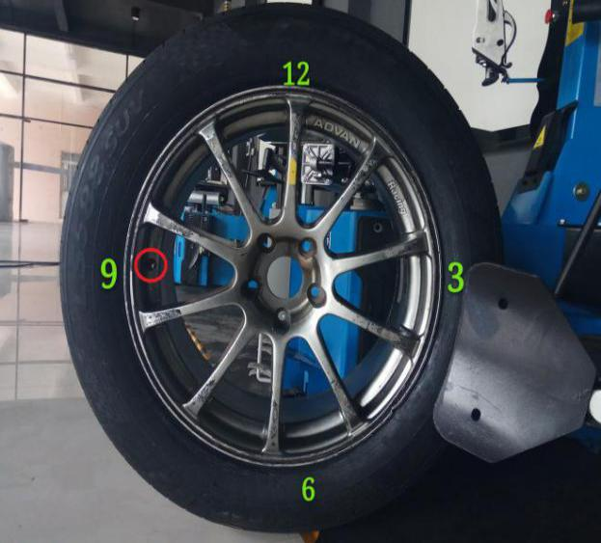

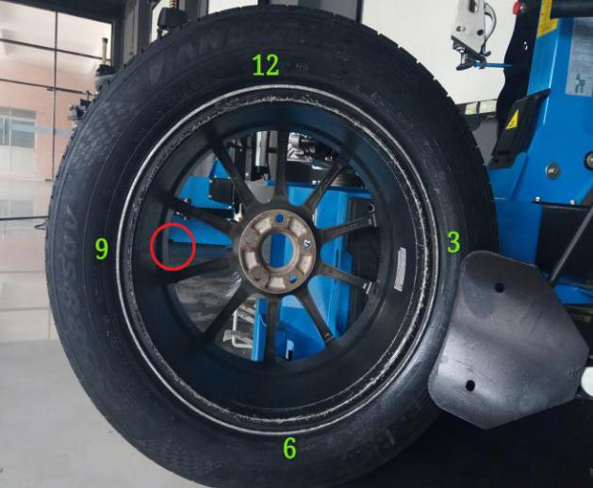

3.Change the opposite side to put the bead breaker.

(Note: put the valve stem at 9 o 'clock position when adjusting, and put the bead breaker on 3 o'clock position, then just clamp down in 12 o'clock and 6 o 'clock position respectively.)

2.Adjust the position of the bead breaker to separate the wheel from the rim according to the tire size.

(Note: put the valve stem at 9 o 'clock position when adjusting, and put the bead breaker on 3 o 'clock position, then just clamp down in 12 o'clock and 6 o 'clock position respectively.)

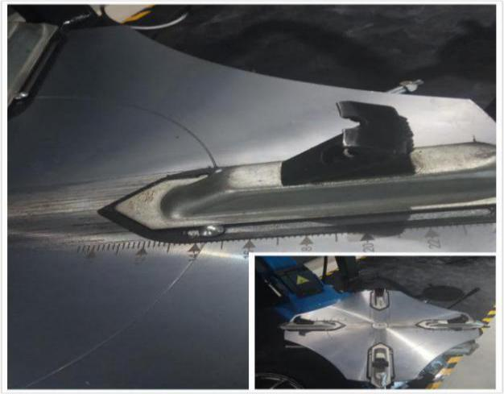

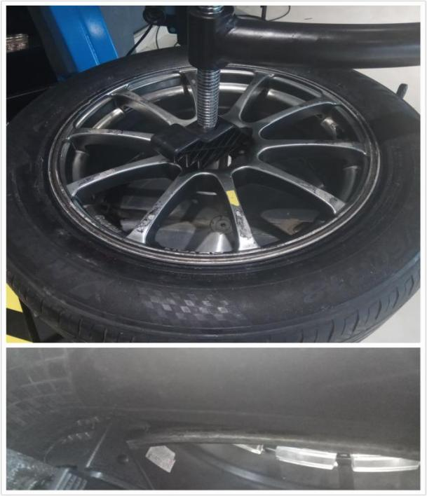

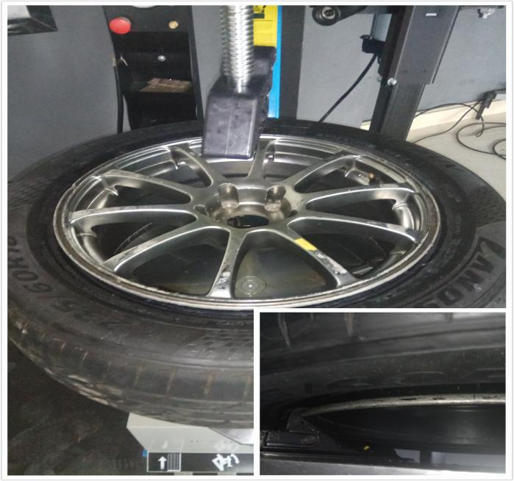

4.Open claws to keep the size slightly larger than the wheel rim’s size.

5.Place the tire with gap on the chuck plate, then down the center position settings on the wheel rim with 10mm distance between.

6.Tighten the claws,elevate the auxiliary arm, even rotate the round plate to check fastness of claws.

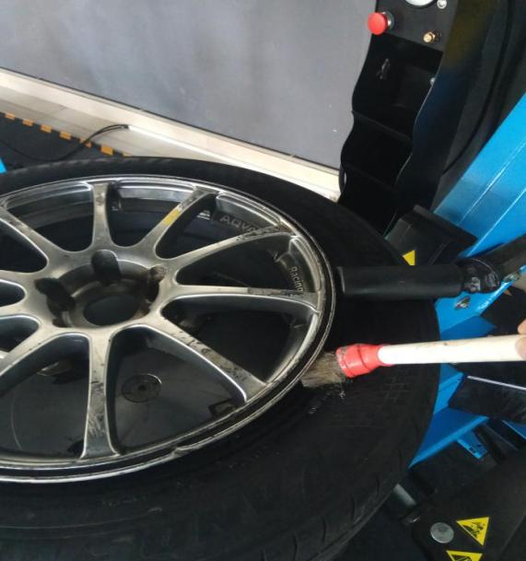

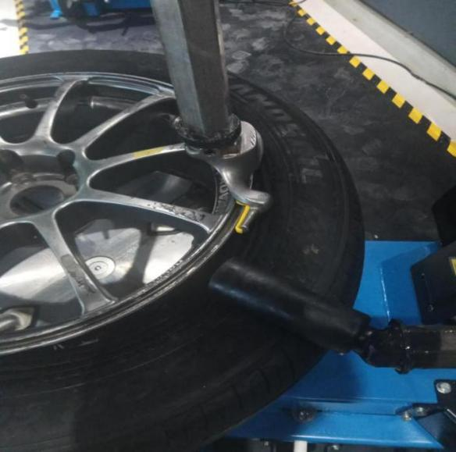

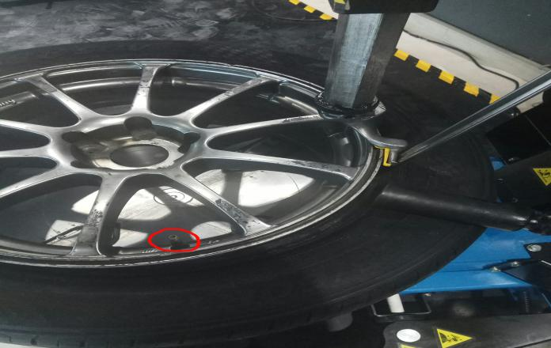

7.Use the auxiliary tire pressure roller with lubricant brush around.

8.Set up the column, adjust high-strength hexagonal removable arm to proper position, make the tire changer assembling head opposite to the position of wheel rim and locks it firmly.

9.The crowbar reaches into the tire.

(Note: The valve nozzle is at 3 o'clock)

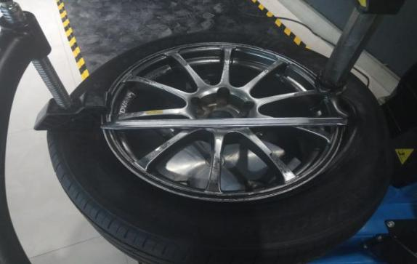

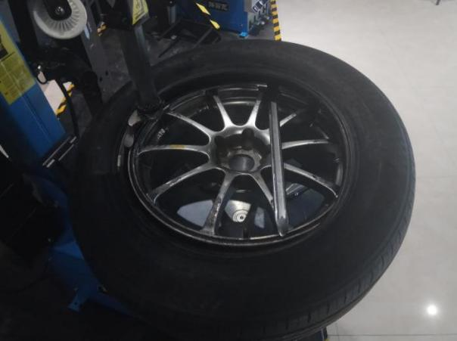

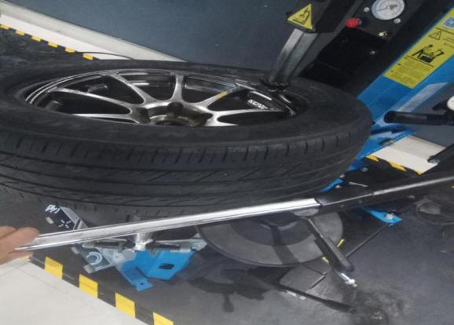

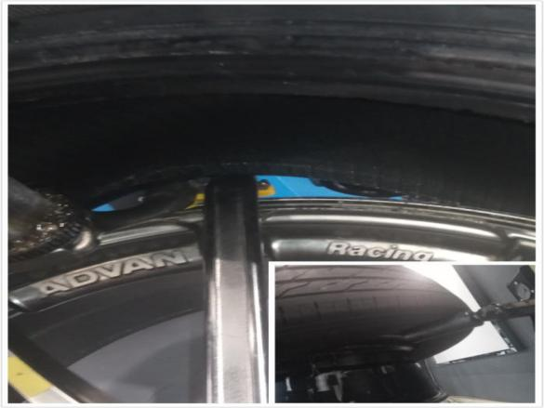

10.Lift the press roller,use the auxiliary tire pressure roller to the opposite side of the tire to make the tire edge up to the auxiliary head, Press the crowbar to keep the tire on the tire head head.

11.Elevate the tire pressure tool and just kick the button in one second to makes the round plate reversing rotation, and then step the button to makes the round plate clockwise rotation to separate the tire and wheel rim.

12.Use the assistant disc to keep the tire and wheel rim completely separated.

13.Use a crowbar under the second layer of the tire and pry the second layer to the head of the bird.

14.Step the button to makes the round plate clockwise rotation to keep the tire and wheel rim completely separated.

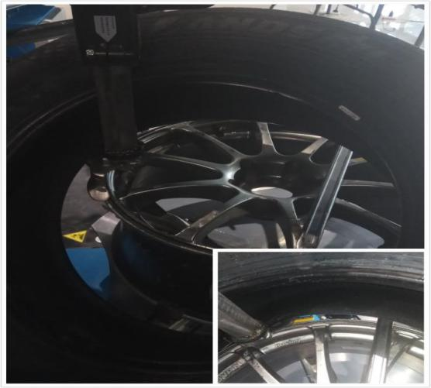

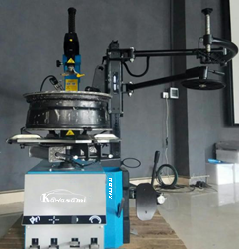

15.Backward curved arms , take down tire and pic up the tire pressure roller .

**Install Tires**

1.Smearing each sides of tires with lubricant.

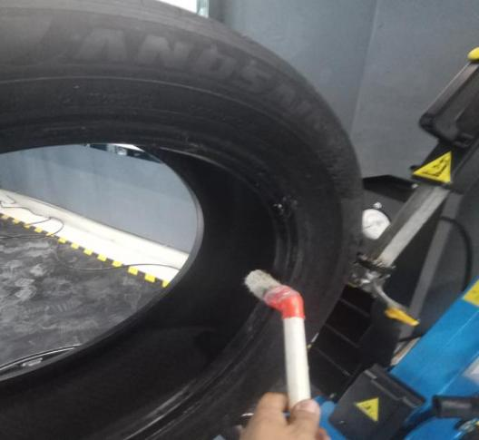

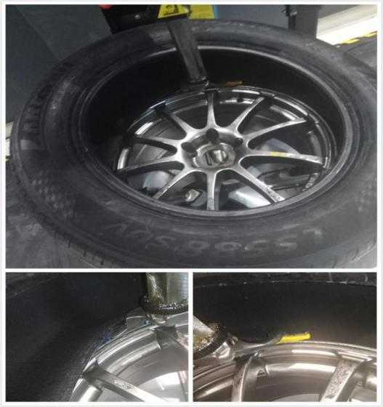

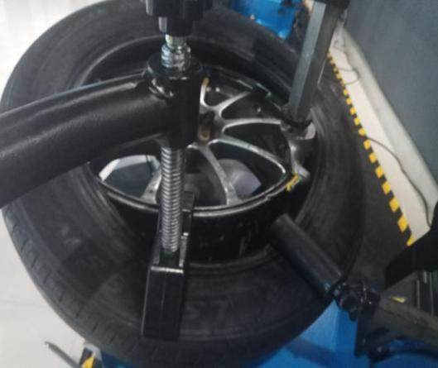

2.Put the tire removal head，Place one end of the first layer tire on the tail of the removed head,The other end is placed under the head of the bird,Step the button to makes the round plate clockwise rotation to keep the first layer of tire completely installed.

3.Place one end of the second layer tire on the tail of the removed head,The other end is placed under the head of the bird,Use both of the auxiliary tire pressure roller and auxiliary arm to press down tires in order to completely installed with the round plate clockwise rotation.

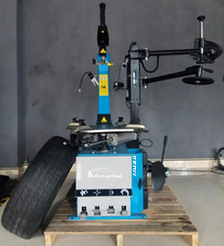

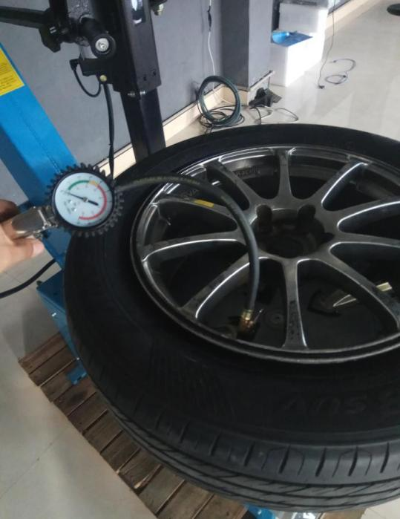

1. Pick up the auxiliary tire pressure roller, the hexahedron bar , and backward curved arms , open claws and take down tires.

5.Inflate the inside of the tire.

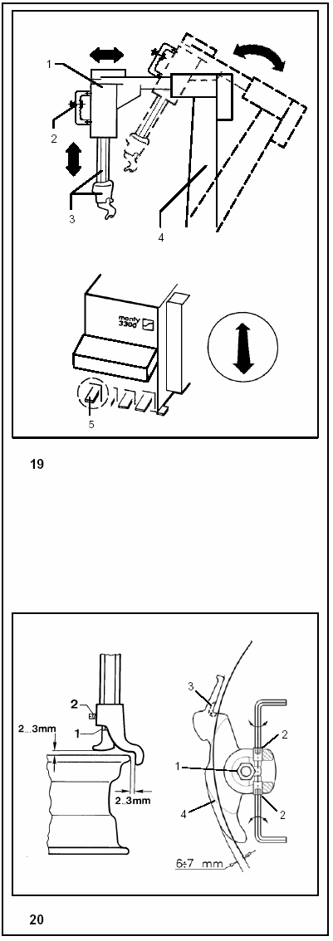

**Setup assembling head**

Before removing and installation, make sure that the assembling head being at the highest position with the assembling head are completely backward pushed.

When handling multiple wheels in same diameter, the assembling head can be in original setting status to work.

Take care to avoid damage when the assembling head working on aluminum alloy hub,what’s more, even it can adjust the gap between the assembling head and the hub effectively, greater than a fixed value.

**Setting Procedure**

1. Don’t remove arm’s horizontal direction.
2. Notice the button of assembling head lock.

3.Vertically adjust the dismantling head chassis with removable head.

4.Tire changer pillar can be tilted.

5.Use the pedal to tilting the pillar

• Fully on the foot pedal to tilting the pillar in proper position.

• Loosen the assembling head lock mechanism device.

• Hand move the assembling head to fixed on the edge of wheel hub, also keep the head nearby the shoulder guide.

• Automatic setting and lock the assembling head,and adjust the height or side clearance by the operating buttons.

**Diameter adjust function, reorient the assembling head’s working position of the hub.**

1 Install the screws of the head.

2 Reorient the role of the linear bolt.

3 Plastic protection (or metal roller)

4 Shoulder guide wheel

In most cases, you should use the hub diameter function to adjust the position of the assembling head when handling oversize tires with a diameter of 12”-24”.

Loosen the assembling head screws and adjust two each linear adjustment pins until the assembling head suitable for current hub.

Tighten the adjustment screw after reorient.



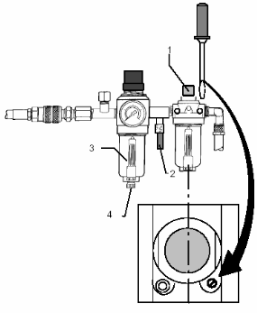

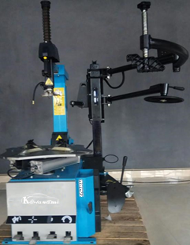

**Maintenance**

Maintenance must be regular and ensure corrected operation, as follows:

1. Clean the machine every day, remove the ordure in the clamping guiding groove and grease lubrication.
2. Check the Oil pot 2-3times everyday. Ensure the oil level inside higher than the oil pot of the suction pipe.

3. Must be filled with the lubricating oil of viscosity 2.5 ° - 7 ° E under the temperature of 50 °C.

4. Check the dose of the lubricant, a drop of lubrication should be dropped Into the oil pan observing glass window after running the pedals

two or three times, if necessary, just adjust the dose screw.

1. Periodically draining water from the water container in the filter, this step is done by counterclockwise ring from the locking action, and there should be separated the machine from the compressed air system every month and clean the water collection in the filter device.
2. At least once a year to clean the bearings, guides and other parts of the dust and dirt just to keep the surface smooth.
3. Annually clean with commercial lubrication maintenance to painting on connecting screws and latches, bearing points, guides, tighten device and other parts.

8. Notice when clean up the glass observation windows only can by water, oil or gasoline (mustn’t by gasoline from petrol stations )

** CERTIFICATION**

Product Name: TIRE CHANGER

Production Model: 

Production Size: 

Production No: 

Production Date： 

Analysis Date: 

The product is tested to meet the standard requirements